# Declaration

I, NEWAY YIFRU, hereby declare that the report entitled Internship report on Ethiopian airlines prepared by NEWAYYIFRU in Addis Ababa and submitted to University industry linkage office of Madda walabu university is as record of original work done by using the internship period of 24-July-2017 to 03-January-2018 under the supervision and guidance of Mr. Arga Sileshy, Mr. Endawoke Senay, Shewit Kahsay, Esayas Semegn and shemelse staff employee in Avionics engineering department.

Name NEWAY YIFRU

Signature

# Acknowledgment

First and to the most i glorify the almighty GOD for everything he gave me success and fruit full time to build myself by practical skills in the internship time. With the deepest gratitude i wish to thank every person who has come in to my life and inspired, touched and illuminated me through their presence.

I take this opportunity to express my profound gratitude and deep regards to my supervisor Engineer Arga Sileshy, Mr. Endawoke Senay, and Esayas Semegn for their exemplary guidance, monitoring and constant encouragement throughout this program. I express my deepest gratitude to staff members of Ethiopian airlines, for the valuable information provided by them in their respective fields .I am grate full further cooperation during the period of my assignment.

# Abstract

This report is all about the six month long industrial internship program that is it contains different topics in the consecutive chapters. Part one is intended to elaborate the hosting companies’ detail that is it tries to describe the brief history, the main products or services, the main customers or the end users of its products or services and the overall organization and work flow of the company. Part two is also about the overall experience I have gained there like how we get into the company, section of the company I was working in and its work flow, the task I have allocated, the challenge faced and measures taken in order to overcome these challenges while doing my task.

Part three describes the benefits I have gained from the program such as benefits gained in terms of improving practical skills, theoretical knowledge, inter personal communication skills and understanding about work ethics related issues. Finally there is conclusion and recommendations on the overall program as seen from my point of view.

Table of Contents

Declaration i

Acknowledgment ii

Abstract iii

List of Figure vi

List of Acronyms vii

CHAPTER ONE 1

1. INTRODUCTION 1

1.1. Ethiopian Airlines Background and Overview 1

1.2. Organizational Structure 3

1.3. Staff Profile 3

1.4. Main products and services of Ethiopian airlines 5

1.5. Company’s customers 5

CHAPTER TWO 6

2. WORK RESPONSIBILITIES AND ASSIGNMENTS 6

2.1. Objective of the Internship 6

2.1.1. General Objective 6

2.1.2. Specific Objective 6

2.2. The Section I Have Been Working On 6

2.2.1. Organizational Structure of Ethiopian MRO Services Division 7

2.3. Work Flow of the Section 7

2.4. Tasks I Have Been Executing 8

2.4.1. Understanding the General Principle of Flight 8

2.4.2. Understanding Aircraft Instruments 13

2.5. Aircraft electrical power system 15

2.5.1. Alternating Current Variable Frequency power supply 16

2.5.2. Main 28 V dc power Generation 17

2.5.3. Battery 18

2.5.4. Auxiliary Power Unit (APU) 18

2.6. Flight Control System 19

2.7. Procedures and Methods Used While Performing the Tasks 21

2.8. My Performance at the Company 21

CHAPTER THREE 22

3. TECHNICAL ASPECT OF THE INTERNSHIP 22

3.1. Objectives 22

3.2. Methods and Procedures 22

3.2.1. Description of starter generator 22

3.2.2. Operation 22

3.3. Aircraft dc Starter Generator Maintenance 23

3.4. Knowledge and Acquaintances Acquired 23

3.4.1. Technical Skills Gained 23

3.4.2. Management skills gained 23

3.4.3. Acquaintances Acquired 23

3.5. Projects and contributions 24

3.5.1. Automatically Identifying Defective Part of Aircraft Coffee Maker 24

3.5.2. Abstract 24

3.5.3. Problem Statement 24

3.5.4. Objective 24

3.5.5. Methodology 24

CHAPTER FOUR 26

4. GENERAL COMMENTS AND CONCLUSIONS 26

4.1. Problems Encountered during the Internship Period 26

4.2. General suggestions and comments to the company 26

4.3. Summary and Conclusion 26

4.4. Recommendation 27

Reference 28

# List of Figure

Figure 1: Organization Structure of Ethiopian airlines 3

Figure 2: Avionics System Engineers 4

Figure 3: Avionics system team leader 4

Figure 4: Organization Structure of MRO Division 7

Figure 5: Aircraft forces 9

Figure 6: Equilibrium level 10

Figure 7: Equilibrium climbing flight 10

Figure 8: Action and Reaction 11

Figure 9: Major parts of Aircraft 12

Figure 10: Aircraft Engine 13

Figure 11: Instruments of the Wright Flyer left and an airbus A380 glass cockpit 13

Figure 12: Instrument system 14

Figure 13: Diaphragm used for measuring pressure 14

Figure 14: Electrical power system block diagram 15

Figure 15: General electric power system 16

Figure 16: AC power supply block diagram 17

Figure 17: DC 28v power generation block diagram 18

Figure 18: Auxiliary power unit block diagram 19

Figure 19: Flight control system 20

Figure 20: Flight control system block diagram 20

Figure 21: Identifying defective part of coffee maker 25

# List of Acronyms

AC………………………………………………… aircraft

AD………………………………………………… Air worseness director

ADC……………………………………………….. Air data module

ADS………………………………………………... air data systems

BPCU………………………………………………. bus power control unit

EO…………………………………………………... engineering order

ESC………………………………………………….. electronic speed controller

FAA………………………………………………….. federal aviation administration

FCM…………………………………………………... flight control management

FCS………………………………………………… … flight control system

GCU…………………………………………………….generator control unit

JIC………………………………………………………job requirement

SB……………………………………………………….service bulletin

# CHAPTER ONE

# INTRODUCTION

## Ethiopian Airlines Background and Overview

The first scheduled flight took place in 8th April 1946 to Cairo via Asmara in Douglas C-47 Skytrain. The national airline had been set up a few months earlier as Ethiopian Air Lines Inc., a joint venture with American airline, TWA (Trans World Airlines). Five US Government surplus C-47 aircraft were purchased for venture. Following the successful inaugural flight to Cairo, a regular weekly service was established. Weekly services to Djibouti and Aden followed, as well as a domestic service to Jimma. Demands for additional services were so great that towards the end of 1946, four more C-47 Skytrains were purchased.

In 1953 three quarters of the airline’s staff were now Ethiopian but expatriates still held most key posts. The Ethiopian government negotiated and new agreement with TWA with ultimate aim of operating entirely with Ethiopian personnel. In 1957 the first Ethiopian commercial aircraft commander, Alemayehu Abebe, made his solo flight as captain on DC-3/C-47 aircraft. The National Airline Training Project was set up with US Government help in Addis Ababa to train local pilots, technicians and supervisory personnel.

The airline established its own maintenance facility at Addis Ababa, reducing the need for maintenance overseas. In subsequent years the facilities expanded into a well-equipped center for maintenance, overhaul and modification work on aircraft, engines and avionic systems, not only for its own aircraft, but also for other airlines in the region.in 1960 the airlines prepared to enter the jet age and decide that the Boeing 720B best met its requirements. However, the existing airfield serving Addis Ababa – Lidetta, which had been built in 1936 - was not suitable for jet operation, which required a long runway, and a decision was made to construct an entirely new airport and headquarters at Bole.

Ethiopian received four Boeing 787 in 2014 increasing the total number of B787 to ten. Ethiopian received two Boeing 777F increasing the total number of B777 to four. Ethiopian took delivery of three Cessna 172 pilot training aircraft. Ethiopian also leased B777-300ER from GE Capital Aviation Services Limited. Ethiopian started new services to Doha-Qatar, Vienna-Austria, Kano-Nigeria, Shanghai-China, Bale Robe & Kombolcha -Ethiopia. Ethiopian also launched four daily flights to Nairobi and daily flights to London. Ethiopian strategic partner for the southern Africa region, Malawian Airlines launched its first international flight to Johannesburg.

Ethiopian received eight different awards during in 2014. Ethiopian won the “Best Airline to Africa” award by Premier Traveler Magazine. Ethiopian won the “Best Foreign Airline of the Year from Africa” by Kuala Lumpur Airport. Ethiopian won the “Airline of the Year” award from African Airlines Association (AFRAA). Ethiopian won ‘Best Airline in Africa” award for the second time in a row from Passenger Choice Awards. Ethiopian won Bombardier Reliability Performance Award for the fourth year in a row. Ethiopian won the “GOLD Level Boeing Performance Excellence Award”. Ethiopian Aviation Academy won the “Airline Training Service Provider of the Year” award from AFRAA. Ethiopian also won the “Best Airline of the Year” award from MICE Magazine in China.

Ethiopian signed code share with ANA, Japan’s leading airline group, United Airlines and Austrian Airlines. Ethiopian Airlines ordered 20 737 MAX 8s from Boeing, the order represents the largest single Boeing order by number of airplanes from an African carrier.

Aviation Academy joined IATA’s global training partner network as an IATA Authorized Training Center. Ethiopian became the largest African carrier by Revenue and Profit according to IATA. In 2015 Ethiopian Airlines phased-in 10 aircraft and has a total of 77 in the fleet Three Boeing 787 Dreamliners, bringing the total number of Dreamliners to 13. Two Boeing 777 - 300 and two Boeing 777-200F, making 15 B777 aircraft in total. Three Boeing 737-800 aircraft, Ethiopian currently has 19 B737 in the fleet.

In 2016 Ethiopian Inaugurated the largest and most modern In-flight Catering Center which covers a total area of 11,500m2, encompassing most-modern operations and food processing area, fully-equipped with high-tech cooking and bakery equipment, large capacity dishwashing and heavy-duty ice-cube machines, hot kitchen, storage units, cold rooms, stores, flow wrapping, loading bays, high lift trucks and vans, varieties of cooling facilities, a dedicated Halal kitchen as well as a number of modern rooms.

Ethiopian 1st Airline in Africa to Receive Airbus A350XWB and First in the World to fly it in African Skies Ethiopian, is proud to be the first airline from Africa to take delivery of the A350 and excel in offering its passengers the ultimate travel experience on-board this aircraft ahead of other carriers. Ethiopian is also pleased to make all Africans proud by being the first airline in the world to fly this ultra-modern airplane in the African skies. In 2016, Ethiopian has received two A350 XWB. Africa’s first, Ethiopian Airbus 350 XWB made its debut flight to Ethiopian destinations including: Yaoundé Cameroon, Kigali, Nairobi, Lagos, Bujumbura, London Heathrow, Douala, Malabo, Southern Africa, Lusaka, Harare, N’Djamena and Entebbe.

ICAO certified Ethiopian Aviation Academy as the ICAO Regional Training Center of Excellence - The Academy attained the recognition following rigorous assessment of the Training organization, Training & Procedures Manuals, Facilities, Training Processes, Qualification of Staff and Quality System.

1. **Vision**

To become the most competitive and leading aviation group in Africa by providing safe, market driven and costumer focused passenger and cargo transport, aviation training, flight catering, MRO and ground services by 2025.

1. **Mission**

To ensure being an airline of choice to its customers, employer of choice to its employees and an investment of choice to its Owner.

To contribute positively to socio economic development of Ethiopia in particular and the countries to which it operates in general by undertaking its corporate social responsibilities and providing vital global air connectivity.

## Organizational Structure

Generally the organizational structure of the company can be depicted as shown in the following figure.

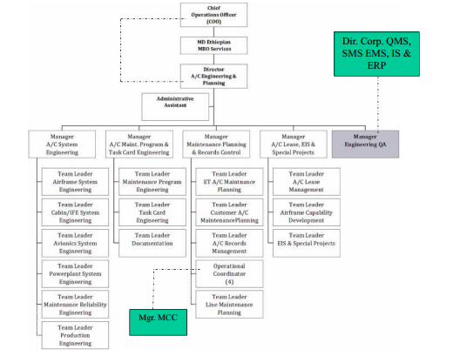

*Figure 1: Organization Structure of Ethiopian airlines*

## Staff Profile

Ethiopian airlines aircraft system engineering and planning department has five sections. I was working on avionics section of the department. The section has also sub sections which have twenty engineers with two team leaders and one manager.

Avionics section sub sections are:

* Group1:- Boeing 767,776,757 and 777 aircraft engineers.
* Group2:- Boeing 787-7,787-8 and 787-9 (new a/c) engineers.
* Group3:- Airbus aircraft engineers.
* Group4:- bombardier aircraft engineers.

I was work in all groups but mainly in group1 because these aircrafts are new and more of mechanical parts are changed by electrical devices.

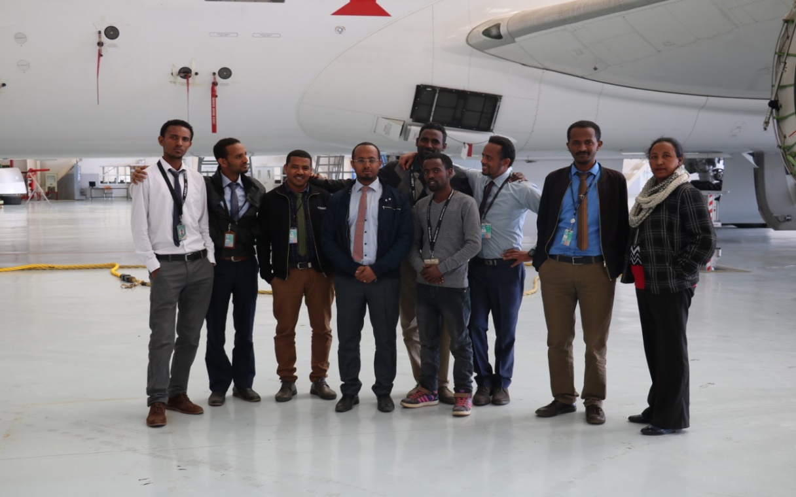

*Figure 2: Avionics System Engineers*



*Figure 3: Avionics system team leader*

## Main products and services of Ethiopian airlines

Ethiopian airlines as a company has many product and services offered to its customers (for country customers and abroad customers.

1. Aviation academy

* Technicians training
* Pilot training
* Engineers training and
* Cabin crew (hostesses) training

1. Passenger and cargo service

* Airport Ticketing Sales Desk
* Ticket Sales and Reservation
* Arrival and Transfer Services
* Check-in Services
* Baggage Check-In and through check-In
* Dedicated Passenger Services
* Gate and Boarding Services
* Lounge Services

1. In-flight entertainment
2. Aircraft maintenance, repair and overhaul.

* Engine maintenance
* Component maintenance
  + Galley (coffee maker) Equipment,
  + Battery and Battery Charges,
  + Starter Generators,
  + Rotary and Linear motor operated Actuators
  + Blowers,
  + Cargo Power Drive Units,

1. Engineering service

* Performing Engine Monitoring & Diagnostics
* Handling engine Fleet Management
* AD/SB monitoring, accomplishment and reports preparation
* Modifications
* Reliability Analysis
* AC Configuration Management

## Company’s customers

The main customers of Ethiopian airlines are:-

* Ethiopian passengers
* Tourists (visitor)
* Big Companies (for their cargo shipping)
* Governmental jobs

# CHAPTER TWO

# WORK RESPONSIBILITIES AND ASSIGNMENTS

## Objective of the Internship

### General Objective

The general objective of the internship course is to facilitate smooth relationship between final year students and industry (company) in terms of technical skill, management skill, communication skill and work ethics.

### Specific Objective

* To receive an introduction of organization within the Information Systems industry and to gain a better understanding of its design and structure.
* To develop an understanding of an organization's various management and technical skills, the communications techniques and the decision-making processes.
* To apply what was learned during coursework (theory, skill development, professionalism) to the working world.
* To allow the Intern to assume responsibilities of a non-Intern staff member and be able to function with a minimum of supervision.
* To help the student make better Information Systems career choices in the future.
* To allow the student to prepare for their future non-Internship job by seeking potential places of employment, practicing resume and cover letter preparation, gaining references, and interviewing if applicable.

## The Section I Have Been Working On

I have been working in the MRO (Maintenance Repair and overhaul) service division in aircraft engineering and planning Department of the company especially in avionics engineering section, in electric (avionics) shop, in radio shop, in instrumentation shops and avionics system engineering department, and sometimes when there is nothing to be done just i read a/c (aircraft) manuals in the documentation room and libraries. Avionics engineering studies about aircraft electrical systems.

### Organizational Structure of Ethiopian MRO Services Division

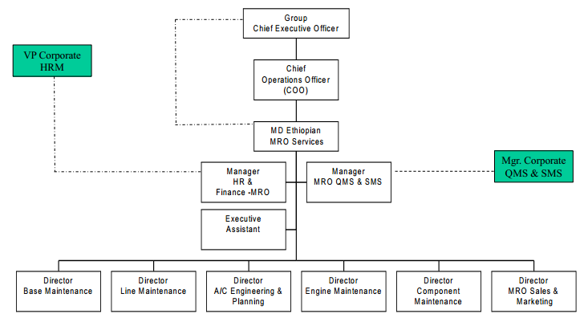

*Figure 4: Organization Structure of MRO Division*

## Work Flow of the Section

To capitalize Ethiopian airlines service to business customers, ET organized a special division fully dedicated to them. This division is called MRO (maintenance, repair and overhaul) division which ensures to businesses to get the best service that enhances their efficiency and profitability. MRO Division consists of different department and sections; Avionics are one of those sections which deal with aircraft electrical part maintenance, repair and modifications. Aircrafts must be checked always because it flies many passengers in air. So avionics sections are always ready to repair, maintain and modify any airplanes. Avionics section is consists of two teams, planning team and Project engineering team.

When there need any modification in aircraft electrical parts due to any cases (aircraft crash, technology update, component fail replacement etc...) the avionics team (engineers) evaluates the existing system and the new system based on federal aviation administration (FAA) rule and then they form engineering order (EO) and job requirement (JIC) for avionics technicians for installation and removal of aircraft component. This EO and JIC is evaluated and approved by avionics system team leader and the budget is approved by aircraft system engineering manager.

The overall modification and maintenance time (schedule) evaluated by planning team by taking each modification needed from avionics engineers. When any modification is issued by engineers then the proposal is evaluated by proposal evaluator team (special project team), after evaluation the project manager approve it and it directly ordered to planning department for implementation schedule.

## Tasks I Have Been Executing

While I stay in aircraft system engineering section the following tasks are done:-

* Visiting airlines aircraft (airplanes),
* Understanding the general principle of aerodynamics and flight,
* Understanding aircraft instruments,
* Understanding aircraft electrical power systems,
* Understanding flight control system,
* Form engineering order and job requirement for technicians,
* maintaining Aircraft Batteries,
* Automatic coffee maker maintenance and modifying galley system of Boeing787,
* Maintain and repair starter generator.

### Understanding the General Principle of Flight

Flight principle of aircraft starts from aircraft aerodynamics, flight control, engine performance and general electrical parts of aircraft. My duty for at list three months is to understand aerodynamic principle of aircraft and electrical part of aircraft like display units, instruments and electrical control actuators.

##### Aircraft Aerodynamics

Understanding why aircraft are designed with particular types of primary and secondary control systems and why the surfaces must be aerodynamically smooth becomes essential when maintaining today’s complex aircraft. The electrical engineer must be able to understand the relationships between how an aircraft performs in flight and its reaction to the forces acting on its structural parts.

Aerodynamics is the study of the dynamics of gases, the interaction between a moving object and the atmosphere. The action of the airflow over a body is a large part of the study of aerodynamics. Aerodynamics is a study of laws which have been proven to be the physical reasons why an airplane flies. The term aerodynamics is derived from the combination of two Greek words: “aero,” meaning air, and “dyne,” meaning force of power. Thus, when “aero” joins “dynamics” the result is “aerodynamics”—the study of objects in motion through the air and the forces that produce or change such motion. To state it another way, aerodynamics covers the relationships between the aircraft, relative wind, and atmosphere; therefor properties of the atmosphere greatly decides the flight of aircraft; like temperature, pressure, density, altitude...etc.

Atmospheric pressure varies with altitude. As an aircraft ascends, atmospheric pressure drops oxygen content of the air decreases, and temperature drops. The changes in altitude affect an aircraft’s performance in such areas as lift and engine horsepower. Air at high altitudes is less dense than air at low altitudes, and a mass of hot air is less dense than a mass of cool air.

Changes in density affect the aerodynamic performance of aircraft with the same horsepower. An aircraft can fly faster at a high altitude where the density is low than at a low altitude where the density is greater. This is because air offers less resistance to the aircraft when it contains a smaller number of air particles per unit of volume. Density varies in direct proportion with the pressure and varies inversely with the temperature.

* **Newton’s Laws of Motion**

The fundamental laws governing the action of air about a wing are known as Newton’s laws of motion.

**Newton’s first low:** low of equilibrium; a body at rest does not move unless force is applied to it. If a body is moving at uniform speed in a straight line, force must be applied to increase or decrease the speed. The tendency of a body to remain in its condition of rest or motion is called inertia. Therefor equilibrium condition is maintained based on four aircraft forces. These forces are weight, lift, trust, and drug; because of these forces there are three moments in three axis; lateral, longitudinal and vertical axis; yaw moment, roll moment and pitch moment.

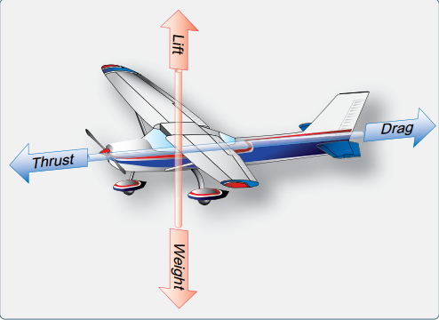

*Figure 5: Aircraft forces*

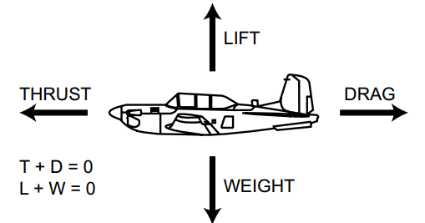

*Figure 6: Equilibrium level*

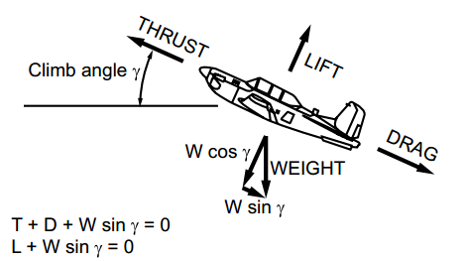

*Figure 7: Equilibrium climbing flight*

An airplane does not have to be in straight and level flight to be in equilibrium. Figure 7 shows an airplane that is climbing, but not accelerating or decelerating, i.e., there are no unbalanced forces. It is another example of equilibrium flight. Thrust must overcome drag plus the parallel component of weight. Lift must overcome the perpendicular component of weight.

**Newton’s second law:** states that if a body moving with uniform speed is acted upon by an external force, the change of motion is proportional to the amount of the force, and motion takes place in the direction in which the force acts, in other word “An unbalanced force (F) acting on a body produces an acceleration (a) in the direction of the force that is directly proportional to the force and inversely proportional to the mass (m) of the body.” i.e. a= f/m. When an airplane’s thrust is greater than its drag (in level flight), the excess thrust will accelerate the airplane until drag increases to equal thrust.

**Newton’s third law** - the law of interaction: “For every action, there is an equal and opposite reaction.” This law is demonstrated by the thrust produced in a jet engine. The hot gases exhausted rearward produce a thrust force acting forward (Figure 8).

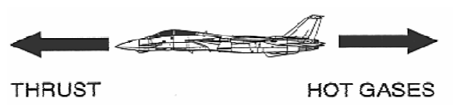

*Figure 8: Action and Reaction*

##### Major Components of an Airplane

The components of a conventional airplane are the fuselage, wings, empennage, landing gear, and engine(s).

**Fuselage:** isthe basic structure of the airplane to which all other components are attached. It is designed to hold passengers, cargo, etc.

**Wing:** is an aerofoil attached to the fuselage and is designed to produce lift. It may contain fuel cells, engine nacelles, and landing gear: Ailerons, flaps and slots are attached with wing.

**Ailerons:** are control surfaces attached to the wing to control roll. Flaps and slots are high lift devices attached to the wing to increase lift at low airspeeds.

**Empennage:** is the assembly of stabilizing and control surfaces on the tail of an airplane. It provides the greatest stabilizing influence of all the components of the conventional airplane. The empennage consists of the till (end) part of the fuselage, the vertical stabilizer, and the horizontal stabilizer. The rudder is the upright control surface attached to the vertical stabilizer to control yaw. Elevators are the horizontal control surfaces attached to the horizontal stabilizer to control pitch (fig 9)

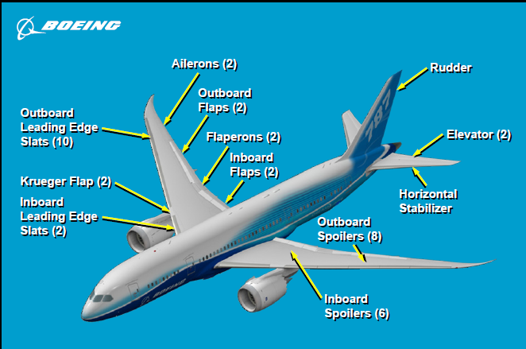

*Figure 9: Major parts of Aircraft*

**Landing gear:** The landing gear permits ground taxi operation and absorbs the shock encountered during take-off and landing. During taxi operations, the nose wheel casters; the airplane is steered using its rudder and/or differential braking.

**Engine:** provides the thrust necessary for powered flight. Military and commercial airplanes may be fitted with multiple turboprop, turbojet, or turbofan engines. The type of engine depends on the mission requirements of the aircraft. Turboprop engine has higher fuel consumption than turbojet engine. Turbofan engine is best in fuel consumption; now a day more aircrafts has turbofan engine.

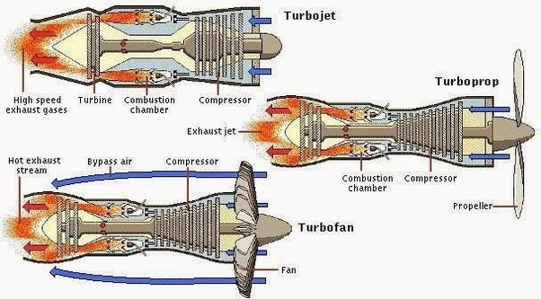

*Figure 10: Aircraft Engine*

### Understanding Aircraft Instruments

Since the beginning of manned flight, it has been recognized that supplying the pilot with information about the aircraft and its operation could be useful and lead to safer flight. The Wright Brothers had very few instruments on their Wright Flyer, but they did have an engine tachometer, an anemometer (wind meter), and a stop watch.

Instrument systems now exist to provide information on the condition of the aircraft, engine, and component, the aircraft’s attitude in the sky, weather, cabin environment, navigation, and communication.

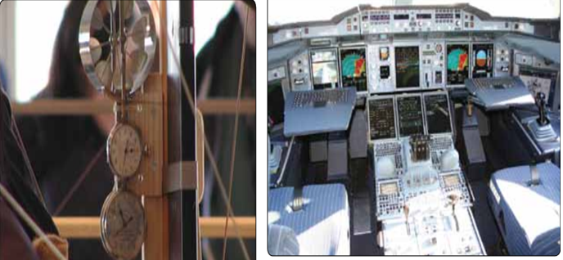

*Figure 11: Instruments of the Wright Flyer left and an airbus A380 glass cockpit*

There are usually two parts to any instrument or instrument system. One part senses the situation and the other part displays it. In analog instruments, both of these functions often take place in a single unit or instrument (case). These are called direct-sensing instruments. Remote-sensing requires the information to be sensed, or captured, and then sent to a separate display unit in the cockpit.

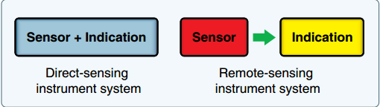

*Figure 12: Instrument system*

There are three basic kinds of instruments classified by the job they perform: flight instruments, engine instruments, and navigation instruments.

**Flight Instruments:** The instruments used in controlling the aircraft’s flight attitude are known as the flight instruments. There are basic flight instruments, such as the altimeter that displays aircraft altitude; the airspeed indicator; and the magnetic direction indicator.

**Engine Instruments:** Engine instruments are those designed to measure operating parameters of the aircraft’s engine(s). These are usually quantity, pressure, and temperature indications. They also include measuring engine speed(s). The most common engine instruments are the fuel and oil quantity and pressure gauges, tachometers, and temperature gauges. Engine instrumentation is often displayed in the center of the cockpit where it is easily visible to the pilot and copilot.

A number of instruments inform the pilot of the aircraft’s condition and flight situations through the measurement of pressure. The two fundamental pressure-sensing mechanisms used in aircraft instrument systems are the Bourdon tube and the diaphragm or bellows.

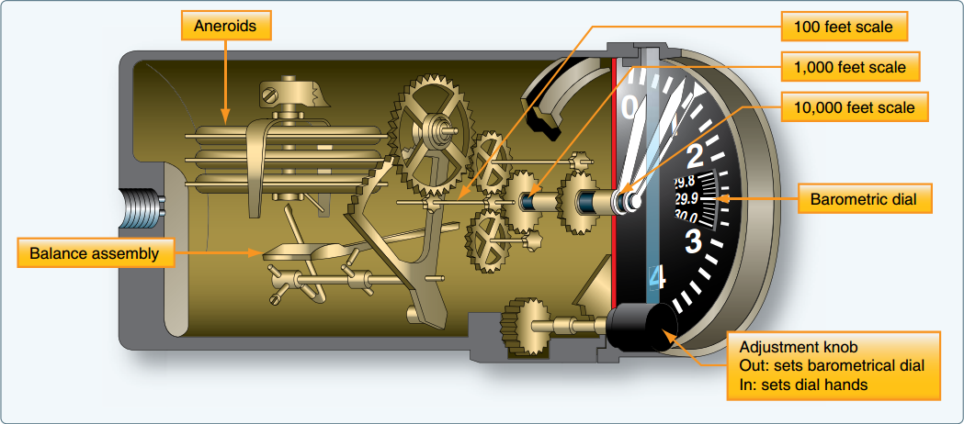

*Figure 13: Diaphragm used for measuring pressure*

## Aircraft electrical power system

The electrical power systems are supplies and controls electrical power to aircraft system. Some systems that operate by hydraulics or pneumatics on other airplanes use electrical power on the 787. The Electrical Power Generation and Distribution System (EPGDS) are used to supply the electrical energy for all onboard electrical equipment. The EPGDS has DC and AC generating systems.

Electrical power sources on an aircraft are classified into three groups:

* Batteries
* External power supply and
* Generators

The DC generation system is supplied by three NiCad batteries, two engine driven starter/generators, two Transformer Rectifier Units (TRUs) and an optional Auxiliary Power Unit (APU). The TRUs supply 28Vdc and are powered by the two engine driven Alternating Current (AC) generator that supply 115 Volts. The ac variable frequency generators make 115 V ac three phase electrical power for ac systems that are not frequency sensitive, such as deicing heaters, fuel auxiliary pumps, the Standby Power Unit (SPU) hydraulic pump and the galleys. It also supplies power to the Transformer Rectifier Units (TRUs), which are part of the direct current (dc) generation system.

There are both DC and AC external power receptacles for Ground Power Unit (GPU) connection. All AC and DC aircraft services can be operated from the AC generators or the AC external power alone

The power is distributed by an electrical bus system. It reconfigures for individual power source and bus failures, by the automatic closing and opening of bus tie contactors.

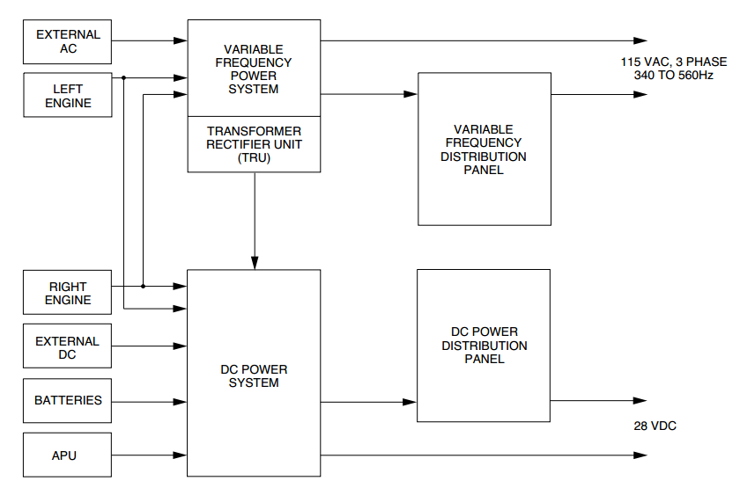

*Figure 14: Electrical power system block diagram*

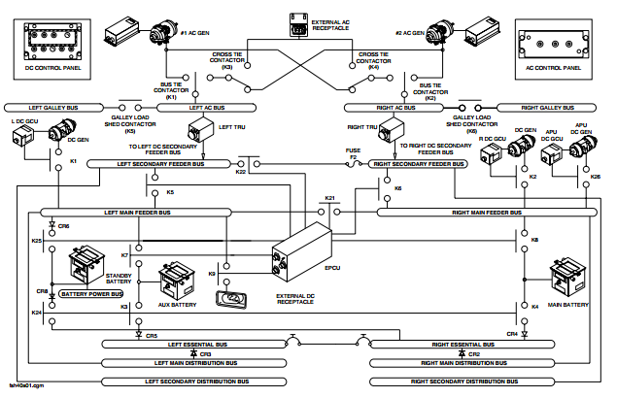

*Figure 15: General electric power system*

### Alternating Current Variable Frequency power supply

Two ac generators are installed, one on each engine, to supply power independently to the left and right ac bus systems. An ac external power receptacle and control circuitry allows the system to be powered from an external power source while the aircraft is on the ground. When one generator malfunctions, the ac variable frequency system automatically connects the two ac busses to the serviceable generator and disconnects the two galley buses. Toggle switches located on the ac control panel in the flight compartment give manual control of the alternating current variable frequency system. The Engine and System Integrated Display (ESID) system shows alternating current variable frequency system electrical indications.

The ac variable frequency system has current sensors in the left and right ac contactor boxes. The current sensors measure A, B, and C phase currents and supplies the data to the Generator Control Units (GCUs) and the Electrical Power Control Unit (EPCU) for monitoring. The EPCU also measures A, B, and C phase voltage from the ac generators and busses.

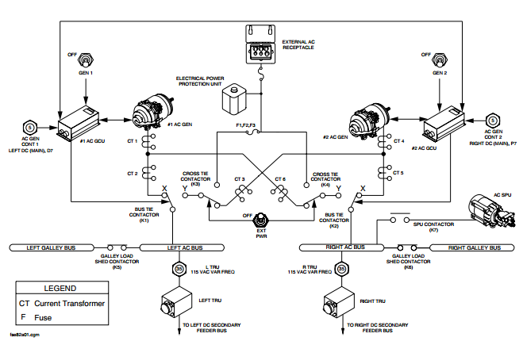

*Figure 16: AC power supply block diagram*

### Main 28 V dc power Generation

The main 28 V dc generation system has two dc starter/generators, one on each engine, and two Transformer Rectifier Units (TRUs) to supply electrical power independently to the left and right dc bus systems. Two dc starter/generators energize their related main feeder and essential distribution busses. The left and right main feeder busses are isolated and are connected to each other automatically or manually through a bus tie contactor. The left and right essential busses are connected together through circuit breakers. Two TRUs energize their related secondary busses. Two engine driven ac generators supply 115Vac variable frequency ac electrical power to the TRUs. The TRUs change the 115Vac variable frequency ac electrical power to 28 V dc power.

When a dc starter/generator or TRU malfunctions, the main 28 Vdc generation system automatically connects its bus to another serviceable electrical source for continuous operation. A dc external power receptacle and control circuitry allows the system to be powered from an external power source while the aircraft is on the ground. Toggle switches located on the dc control panel in the flight compartment give manual control of the main 28 Vdc generation system. The Engine and System Integrated Display (ESID) system shows main 28 Vdc generation system electrical indications.

Generally the main 28 Vdc generation system has five internal power sources and one external power source that follows:

* Left TRU
* Right TRU
* #1 DC starter/generator
* #2 DC starter/generator
* Batteries, main, auxiliary and standby
* DC external power

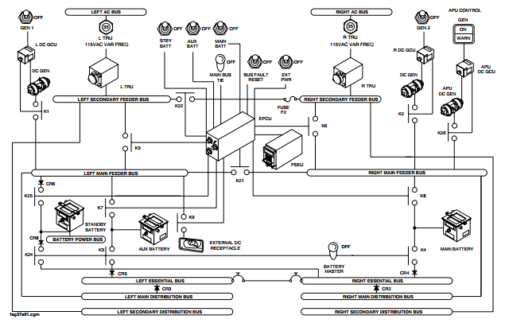

*Figure 17: DC 28v power generation block diagram*

### Battery

The batteries are used for engine starting if ground power is not available, and to supply backup power to the aircraft essential services in flight for 30 minutes or more (60 minutes with 40−amp−hour standby battery). The connections of the main and auxiliary batteries to the main buses are controlled by the EPCU logic.

### Auxiliary Power Unit (APU)

The APU Starter/generator is located in the tail cone section of the aircraft. The APU is designed to supply 28Vdc to the essential and main DC buses on the ground. After the APU is started, the starter/generator is available to supply power in parallel with the batteries to assist start the aircraft engines.

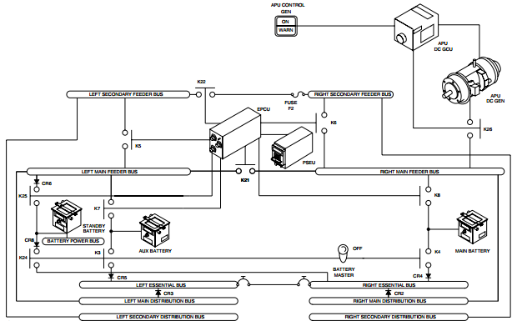

*Figure 18: Auxiliary power unit block diagram*

## Flight Control System

The flight control system controls the movement of airplane (roll, pitch, and yaw) in all phases of flight. The flight control system is a fly-by-wire (electrical controlled) control system with digital and analog signals. The flight control software is in the flight control electronics (FCE). The flight control function (FCF) provides control for airplane pitch, roll, and yaw. The flight control electronics (FCE) calculate control surface commands based on input signals from: Control columns, Control wheels, Rudder pedals, Pitch trim switches and Airplane sensors. The control surface commands go from the FCEs to electronic actuators at the control surfaces for the desired airplane response.

The control surfaces are: Ailerons (2), Flaperons (2), Spoilers (14), Elevators (2), Rudder, Flaps (4), Slats (14) and Krueger flaps (2).

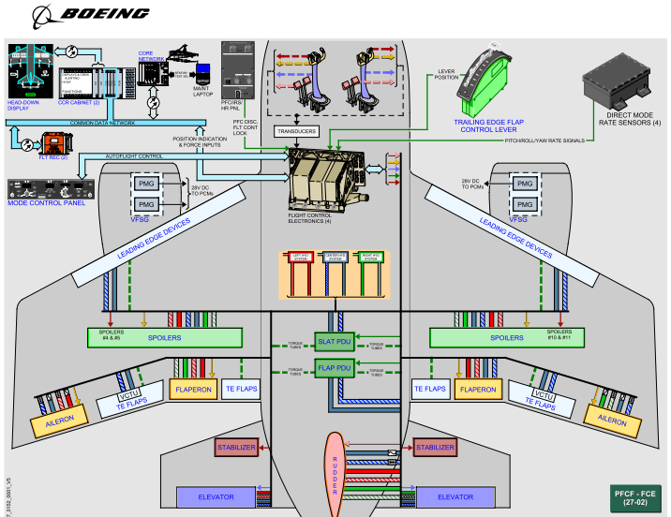

*Figure 19: Flight control system*

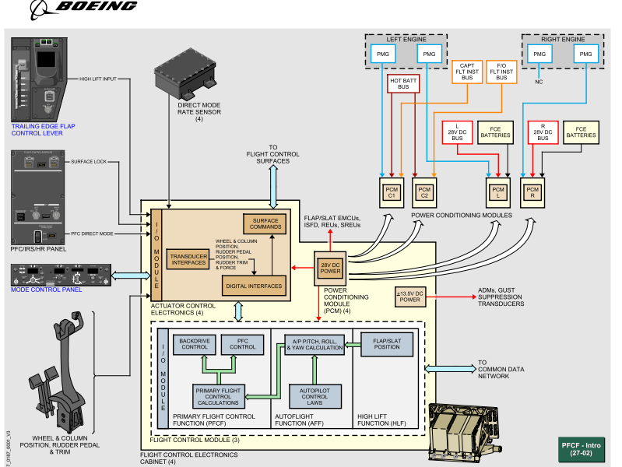

*Figure 20: Flight control system block diagram*

## Procedures and Methods Used While Performing the Tasks

While I was staying in the company I understand the working principle of electrical devices in aircraft and the aircraft itself. First and for most I visualize the aircrafts, its control surfaces, its engines, its landing gears and its wings shape repeatedly by touching it. And then by the schedule they give for me I study the general principles from their engineer’s book and then they evaluate me after my study.

## My Performance at the Company

My performance at the company is that after visualizing and understanding operation of aircraft and electrical components of aircraft maintaining and repairing components and creating engineering order.

# CHAPTER THREE

# TECHNICAL ASPECT OF THE INTERNSHIP

## Objectives

The main objective of this task is to maintain and overhaul dc starter generator and checking its efficiency.

## Methods and Procedures

The dc starter generator is designed to operate in two states, like motor and like generator based on its inputs.

### Description of starter generator

* Diameter of starter generator is 6.21in (15.8cm)
* Weight of 19.05kg
* Output voltage (generator) 30v dc
* Current 400A
* Speed range (motor) 12,000rpm
* Self-air cooling fan
* Input voltage 28v and current 2,000A
* Shunt (wound ) machine

The dc starter generator is designed to operate in an electrical system consisting of two turboprops driven air cooled dc starter generators, and as an option APU turbo engine driven air cooled dc starter generator.

The dc starter generator must operate as a starter motor to achieve turbo engine starting and following starting must operate as a generator to supply aircraft dc power requirements.

This generator is controlled by generator control unit (GCU)

GCU provides:

* engine start control
* generator regulation and
* system protection

### Operation

1. **Starter mode**

Dc starter generator act as starter (motor) under GCU control. Power to achieve engine starting is available through the main bus from either on board batteries, other operating dc starter generator, or dc external power.

When commanded to start the GCU applies the appropriate field to the dc starter generator and closes the line contactor.

1. **Generator mode**

Normal operation requires the dc starter generator, under the control of the GCU, to self-excite and attain stable regulated output. Upon achieving regulated output, the GCU closes the line contactor and connects the dc starter generator output to the main bus.

## Aircraft dc Starter Generator Maintenance

The dc starter generator has its own tester and simulator for echo types of aircrafts (Q400, airbus, Boeing…)

The tester simulates the proper output voltages when using like generator and output torque when using like motor.

**Brush run up:** to see the normal setup of brush in the commutator top. This test is done by seeing the resistance of the brush on the commutator. That means by supplying voltage to the starter motor, checking the current delivered by the motor.

If the brush is seated in good condition the current is up to 29A at 28v; if not, run up until it comes to 29 ampere of current.

## Knowledge and Acquaintances Acquired

### Technical Skills Gained

The Ethiopian airlines company has a lot of huge equipment’s and gives different services for customers. According to this I have gained a big practical knowledge about control system and power electron (drive system) service, system response and so on.

### Management skills gained

The management system of Ethiopian airlines is example for other company, especially avionics section; they show me how to communicate and how to make work hierarch with teammates. Avionics system leader shows me how to manage myself and co-workers too.

### Acquaintances Acquired

Ethiopian airlines engineering and planning department in avionics section I made some link with:

* Avionics Systems Engineering team leader Arga Sileshy

([argaS@ethiopianairlines.com](mailto:argaS@ethiopianairlines.com))

* Aircraft Maintenance program engineering supervisor Esayas Semegn

([EsayasS@ethiopiansairlines.com](mailto:EsayasS@ethiopiansairlines.com) )

## Projects and contributions

### Automatically Identifying Defective Part of Aircraft Coffee Maker

### Abstract

Aircraft coffee maker is one type of aircraft galley system. The coffee maker is automatically makes coffee and tea. However, the coffee maker has repeated errors for coffee as well as tea because of its valves are closed when different temperature is applied to it; also it is difficult to know which solenoid valve is not working without opening it and it is difficult to check the problem without opening each cage, so this project identifies the problem of coffee maker and troubleshooting the problem automatically by using flex sensor in side solenoid valve.

When there is any problem the screen shows which component is defective (problem) and after that anyone can simply maintain it.

### Problem Statement

Aircraft coffee maker always faces problem and the error is difficult to identify in short time of period, because the solenoid valves are more than ten in one coffee maker, so to know which solenoid is defective we have to open each solenoid and this takes time to maintain and also cost of maintenance

### Objective

* **General objective**

The main objective of the work is to make cost effective, time saving and reliable automatic fault identification and troubleshooting system of automatic coffee maker.

* **Specific objectives**
* Improving maintenance time.
* Improving cost of maintenance.
* Improving human power for maintenance.
* Flexibility and reliability.

### Methodology

The aircraft coffee maker has the following parts:

* Solenoid valves
* Keypads
* LCD display
* Micro Processor
* Driver circuit
* Power circuit
* Temperature sensors
* Pressure sensor
* Flex sensor

The solenoid valve is an electromechanical system and the spring that holds the valve changes is spring compression and expanding properties due to this problem the valves may not open and transfer water through the plastic tube. To check which solenoid is not working i introduce a flex sensor inside a solenoid valve in the spring; this flex sensor changes its resistance depending on its stresses and its expanding rate.

The flex sensor fed its value for processor and by calculating the resistance of the flex sensor the processor displays which solenoid is defective.

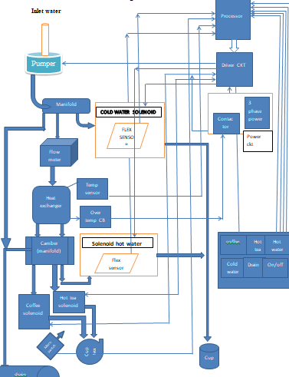

*Figure 21: Identifying defective part of coffee maker*

# CHAPTER FOUR

# GENERAL COMMENTS AND CONCLUSIONS

## Problems Encountered during the Internship Period

I challenged some problems at time of performing my work tasks. When I was in campus I did not studied and learned the electrical devices which found in my hosting company, but the electrical components on the machines are not new for me because I learned in the class. Since I am student, it was difficult for me to know all the electrical instruments, means that some are new.

The other problem I faced during internship period is:

* Pocket money is not that much enough in my internship environments, because everything is expensive there.
* Transportation problem is very challenging, been punctual is difficult, service is not given for students.

## General suggestions and comments to the company

Ethiopian airline is amazing company in terms of capital, salary, work ethics, and management and carrier developments. I am proud to have time with them. Generally during this program I have seen different things. Thus for such occasions I am intended to recommend the company the following:

* It has to give a task (that is participating both in field and office works as required) for those interns to execute independently as it enhances their responsibility.
* Strictly follow up the performance and punctuality of interns in their task execution.
* If there is pocket money for interns, because everyone is not came from hosting company area.
* If there is also transport service for students, it is good for perfect punctuality.

## Summary and Conclusion

A source indicates that an Ethiopian airline was established before seventy years ago and it’s the biggest and well organized governmental company in Ethiopia. As I have got more information in this Internship period Ethiopian airlines is the back bone for the transformation by the side of technology and to facilitate every movement in market, product, tourism and etc. Also the services of Ethiopian airlines are very wide and basic for our country development. As I specify and observe aircraft control system in my last six months in avionics section.

I better conclude what I really observe during my entire internship period, I have got so much important knowledge’s as well as awesome experiences. The internship program have great role on shaping my future goal and vision. Also the internship is better for knowing the external work environment, solving challenges that face during work times; developing good inter personal communication skills, entrepreneurship skills, necessity of work ethics and also developing my practical and theoretical knowledge.

The internship is very important for engineering students by every direction to develop the interest to learn more at the next time and to be having a good vision about future and make me to develop new ideas. I got a good knowledge and I decide to do more on aerospace engineering to be the next generation strong worker.

## Recommendation

To make the company more profitable and increase the capacity the following problems have to be solved

* Automatic temperature control in battery room.
* Practice preventive maintenance to use machines for a long period of time.
* Proper screening of new employees who have high skill to perform tasks satisfactorily and give training to aware about the intended position.

Non responsibilities for internship student they didn’t prepare infrastructure for us like Wireless internet service, transportation, pocket money. They must consider this and they may be gained solution for their problems.

# Reference

1. Ethiopian airlines aircraft manual
2. Federal aviation administration manual
3. [www.ethiopianairlines.org](http://www.ethiopianairlines.org)